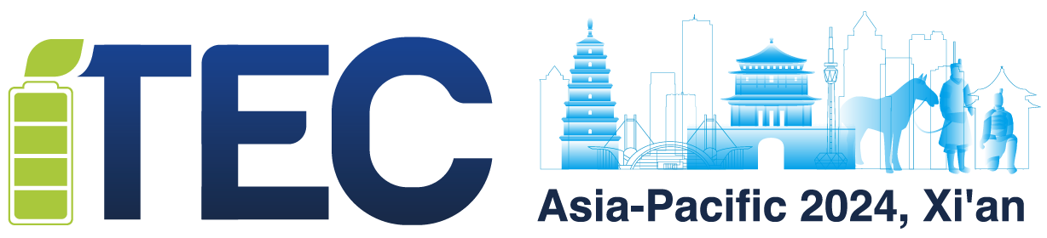

**2024年IEEE亚太地区交通电气化会议及展览会**

(2024 IEEE Transportation Electrification Conference and Expo, Asia-Pacific)

Xi’an, China / 中国，西安

October. 10-13 ,2024 / 2024年10月10-13日

#### Call for Tutorial Proposals

#### Tutorial Proposal Submissions

2024 IEEE Transportation Electrification Conference and Expo, Asia-Pacific (ITEC-AP 2024) solicits proposals for 3 hours Tutorials that complement the regular program with clear and focused coverage in new and emerging topics within the scope of conference. Tutorials are an opportunity for researchers, developers and practitioners from academia and industry to learn about the state-of-the-art research.

##### How to Submit Tutorial proposal

* Tutorial proposals should be submitted by the prospective Tutorial Speaker (s).
* Tutorial Length: 3 hrs
* All Proposals will be peer reviewed.
* Each proposal must fill in the following form and send to ITECAP@vip.163.com

#### Important dates for Tutorial proposal submissions

* Tutorial proposal submissions: May. 30, 2024
* Proposal acceptance notification: July. 31, 2024
* Tutorial Date: 14:00-17:00, October 10, 2024



|  |  |  |
| --- | --- | --- |
| Tutorial Proposal Form | | |
| Tutorial Speaker Name |  | Photo of Tutorial Speaker |
| Email |  |
| Cell Phone |  |
| Affiliate & Title |  |
| Title of Tutorial |  | |
| Description of the Tutorial Proposal | * Objectives and motivation * Novelty, highlighting the technical innovations presented in this tutorial * Tutorial content, indicating the topics that the tutorial will cover in detail | |
| Abstract |  | |
| Bio(200 words) |  | |